First Presbyterian Church
Durham, North Carolina
Eighth Sunday after Pentecost |  | July 19, 2026

A Service for the Worship of God
(As we prepare to worship, please silence all mobile devices.)

Welcome and Announcements, Joys and Concerns |  |  |  |  | Mindy Douglas
Minute for Mission |  |  | Red Cross Blood Drive |  | Cassandra Hett
Prelude | Adagio in E Major Frank Bridge
*Call to Worship |  | (from Psalm 139) |  | Mindy Douglas
Leader: People of God, let us gather to worship and praise God’s name.
People: We give thanks to God with our whole hearts.
Leader: For great is God’s steadfast love for us.
People: The Lord has delivered us from the depths.
All: Come, let us worship God!
*Hymn No. 265 | (See Insert) |  | Jesus Shall Reign Where’er the Sun |  |  | Duke Street
*Confession of Sin |  | Esther Hethcox
Call to Prayer
Prayer of Confession
Merciful God, your creatures cry and creation groans,
but we turn away.
We surround ourselves with noise.
We are quick to excuse ourselves from responsibility:
we are young; we are old;
we are tired; we are busy.
It is hard to imagine that we might make a difference.
Life-giving God, wash us clean.
Restore our imaginations and our hearts.
Let your courage and compassion flow through our veins
until we love with abandon
and our hands reach out in blessing,
for creation waits with eager longing
for the revealing of the children of God.
Silent Confession
Assurance of Forgiveness
*Passing of the Peace
*Regathering Hymn No. 399 |  |  |  | God Welcomes All | Themba Amen
*Those who are able, please stand.
Collect |  |  |  |  |  |  |  |  |  | Michael Honeycutt
Leader: The Lord be with you.
People: And also with you.
Leader: Let us pray.
All: Eternal God,
Your love for us is everlasting;
you alone can turn the shadow of death
into the brightness of the morning light.
Help us turn to you with believing hearts.
In the stillness of this hour,
speak to us of eternal things,
so that, hearing the promises in scripture,
we may have hope and be lifted above our distress
into the peace of your presence;
through Jesus Christ our Lord. Amen.
Hebrew Scripture Reading  Leader: The Word of the Lord.  People: Thanks be to God! |  |  |  |  |  |  | Isaiah 44:6-8 | (Pew Bible, OT Page 673)  Michael Honeycutt
Epistle Reading  Leader: The Word of the Lord.  People: Thanks be to God! |  |  |  |  |  |  | Romans 8:12-25 | (Pew Bible, NT Page 158)  Mindy Douglas
Sermon |  |  |  | “Creation Groaning” |  |  |  |  |  |  |  |  |  | Mindy Douglas
(silent reflection)
*Affirmation of Faith |  |  |  |  |  |  | From the Proposed New Confession of Faith Sam Miglarese
Together as the body of Christ, forgiven and forgiving one another,
we break down boundaries established by worldly powers,
see those deemed invisible,
touch those deemed impure,
name and denounce false gods,
and embody the table-turning power of divine love.
As stewards of God’s creative work,
we repair and nurture the earth we have harmed,
tending it for future generations,
and we honor our own life-giving connection
to the rest of creation.
As we feel the earth groaning in labor pains,
we proclaim our steadfast hope that a new creation is being born,
and we eagerly await the new heaven and earth,
when the home of God is among mortals
and death will be no more.
*Hymn | (Page 6) | For the Healing of the Nations |  |  |  |  |  | Lauda Anima
Time with The Children |  |  |  |  |  |  |  | Esther Hethcox

Dedication of Offerings
Invitation to Give |  |  |  |  |  |  |  |  | Sam Miglarese
Offertory |  |  |  |  |  | St. Philip |  |  | Healey Willan
*Doxology with Alleluias Lasst Uns Erfreuen
Praise God, from whom all blessings flow;
Praise God, all creatures here below; Alleluia; Alleluia;
Praise God above, ye heavenly host;
Creator, Christ, and Holy Ghost. Alleluia!
Prayers of the People and The Lord’s Prayer (In unison) |  |  |  |  |  |  |  |  |  |  | Sam Miglarese
Leader: In Christ we are no longer strangers,
People: we are members of the household of God.
Leader: Let us pray.
(Prayers of thanksgiving and intercession)
Our Father who art in heaven, hallowed be thy name. Thy kingdom come, thy will be done, on earth as it is in heaven. Give us this day our daily bread; and forgive us our debts, as we forgive our debtors; and lead us not into temptation, but deliver us from evil. For thine is the kingdom and the power and the glory, forever. Amen.
*Hymn | (Page 7) |  |  |  | Wash, O God, Your Faithful Children |  |  |  |  |  |  | Beach Spring
*Charge and Benediction |  | Mindy Douglas
*Postlude | To You, Jehovah, I Will Sing |  | Max Drischner
Today at FPC

 | First Presbyterian Church welcomes all who worship with us.  Let us know you have joined us for worship by scanning the QR code to the left. For online giving, scan the QR code to the right. | 
Sign In |  | Donate Online
We honor and celebrate the human diversity and unity that God gives us in Jesus Christ. First Presbyterian welcomes individuals of every age, race, nationality, gender identity, ability, sexual orientation, and economic circumstance to participate fully in the life of the church.
So that you may know who is sitting nearby, please sign the Friendship Pad, pass it along the pew,
and then return it to the starting point, noting the names of those sitting near you.
The flowers are given to the glory of God and in memory of Amy Wilson’s father, James Perry Allen and her grandmother, Julia Allen, by Gray, Amy, Julia, James, and Anna Wilson.
Flower Donation Opportunities Available: There are open dates for worship flower donors in September. To sign up, visit bit.ly/FPCflowers26 or click on the flowers link in the bi-weekly newsletter.
A special thanks to our guest organist, Gordon Campbell. Gordon is a member at FPC and a regular substitute organist. Thank you, Gordon! Thanks also to Sam Miglarese, former associate pastor (retired) at FPC for his leadership today. Thank you, Gordon and Sam!
Portions of today’s worship resources are the proposed New Confession of Faith, Feasting on the Word, and the Book of Common Worship. Music is reprinted under Onelicense.net: A.713926.
Childcare: A staffed nursery and children’s playroom are available on the second floor of the education building during worship. Activity bags and baskets are available in the foyer for children. Please return them to the foyer at the end of worship.
Restroom locations: To the left and right as you exit the rear of the sanctuary; on the first and second floors of the education building; and on the first and second floors of the church house. There is an infant changing table in the restroom area located to the left as you exit the rear of the sanctuary.


Upcoming Events
Many of our events are posted in the bi-weekly newsletter. You may read past newsletters and join our mailing list at https://firstpres-durham.org/weekly-newsletter/
Ladies Tea: All ladies of FPC Durham are invited to join the Fellowship Committee for well-brewed teas and delightful tea-time treats on Saturday, July 25 at 1:00 p.m. To bring a treat to share, savory or sweet, sign up at https://tinyurl.com/ladies-tea-2026.
Yoga meets this week. Contact Jane Wettach for more information at janewettach@gmail.com.
Critical Blood Shortage: FPC Durham is hosting a blood drive Thursday, July 23 from 1:00–6:00 PM. Blood donors are urgently needed to give now to help ensure patients receive lifesaving medical care without delay. The shortage comes during the height of trauma season, when hospitals frequently see increased demand for blood due to serious injuries and other medical emergencies.
Every Drop Matters. Every Donor Counts.
Please make your appointment today: https://tinyurl.com/fpc-durm-blood-drive-26
Urban Ministries of Durham: We need volunteers to help us make and serve breakfast and lunch at Urban Ministries of Durham.﻿ We make bag lunches twice a month from 9:30 to 10:30, and we make and serve breakfast once or twice a month from 7:00 to 9:00.﻿ We will team you with a seasoned volunteer who will guide you through. If you are interested in being on the sign-up list, please contact ﻿Jancy Johnstone, 919.824.6489 or jancyjohnstone@gmail.com.
Health Awareness & Health Equity Event in Honor of Denisha Williams: Covenant Presbyterian Church will host a Health Awareness and Health Equity Event on Thursday, July 23, from 6:30 to 8:30 p.m., held in honor of Denisha Williams, daughter of our own Sybil King. The evening will focus on recognizing warning signs that should not be ignored and understanding when and how to follow up with a doctor. The event will be at Covenant Presbyterian Church, 2620 Weaver Street, Durham, NC. ﻿
Cantanti North Carolina Presents “Inflections”: Saturday, August 2 at 2:00 p.m. in the Sanctuary. A choral concert exploring the moments that change us, presented by Cantanti North Carolina. Admission is free with a suggested donation of $5, benefiting Urban Ministries of Durham. All are welcome.
~ Celebrations and Concerns of the Congregation ~
Celebrations:
JoAnn and Fred Moore welcomed grandson Shepherd Frederick Dille, son of Laura and Mark Dille, on July 11.
Omar Guess welcomed grandson Colen Guess, son of Damir Guess.
We remember in prayer:
Susan Cyr, who is currently receiving care at Duke Medical Center.
Ann Huff, as she prepares for her upcoming surgery.
Charlie Kelley, who is recovering from hospitalization for a collapsed lung.
Sara Radtke, who is recovering from eye surgery.
The mother-in-law of Donald Turner, who is currently hospitalized.
Tony Brown Paul Cornsweet Sam Crabtree Sue Fricks
Christy Gudaitis Elizabeth High Kerry Holbrook Lee House
Elizabeth Manceras Harriett Mitchell Fred Moore Jim Rogers
Franzi Rokoske
Care Communities:
Croasdaile Pavilion: Dub Gulley, Alfred Tisdale | Durham Ridge: Phillip Herndon
Hillcrest Convalescent: Carol Wills | Pruitt Health - Durham: Fred Callaway
Brookdale Senior Living: Debbie Mathews | Southpoint Atria: Madge McKeithen
Chatham Ridge Assisted Living: John Fricks
Family and Friends of the Congregation

Ashley Alvord, colleague of Sharon Hirsch
Francisca Cristobal, relative of Al and Judy Arrowood
Kim Cummings, father of Drew Cummings
Sara Degand, cousin of Deborah Momsen-Hudson
Minnie Sue Douglas, mother of Mindy Douglas
Rosalynn Farrell, mother of Rachel Bethune
Linda Foster-Momsen, mother of Deborah Momsen-Hudson
Cheryl Fowler, friend of Cheri Reece
Jennifer Hervey, daughter-in-law of Jeanne Hervey
Donna Holladay, friend of Jane & Robert Brawley
Katie Jackson, wife of Matthew Hirsch
Donna Johnson, mother of Ann Huff
Edward & Meryl Keenan, brother and sister-in-law of Mary-Jo Keenan.
Anthony Ketcham, brother-in-law of Wil James
Sandra Mikush, mother of Katie Fogleman
Ana Sofia Ochoa, family member of Becky Martin
Patrick O’Neill, father of Brianna Bennett
Janet and James Ouzts, sister and brother-in-law of Celia Dickerson
Rebecca Todd (“Toddie”) Peters, mother of Sophie Peters
Bill Prochaska, friend of Al and Judy Arrowood
Annie Reaves, great-niece of Floalice and Robert Reaves
Joe Quirk, stepfather of Tim O’Brien
Vivian Turner, mother of Donald Turner
Jim Vacca, father of Jamie Chambliss
Newton Wong, nephew of Paul Lee

Hymn No. 265 | Jesus Shall Reign Where’er the Sun | Duke Street
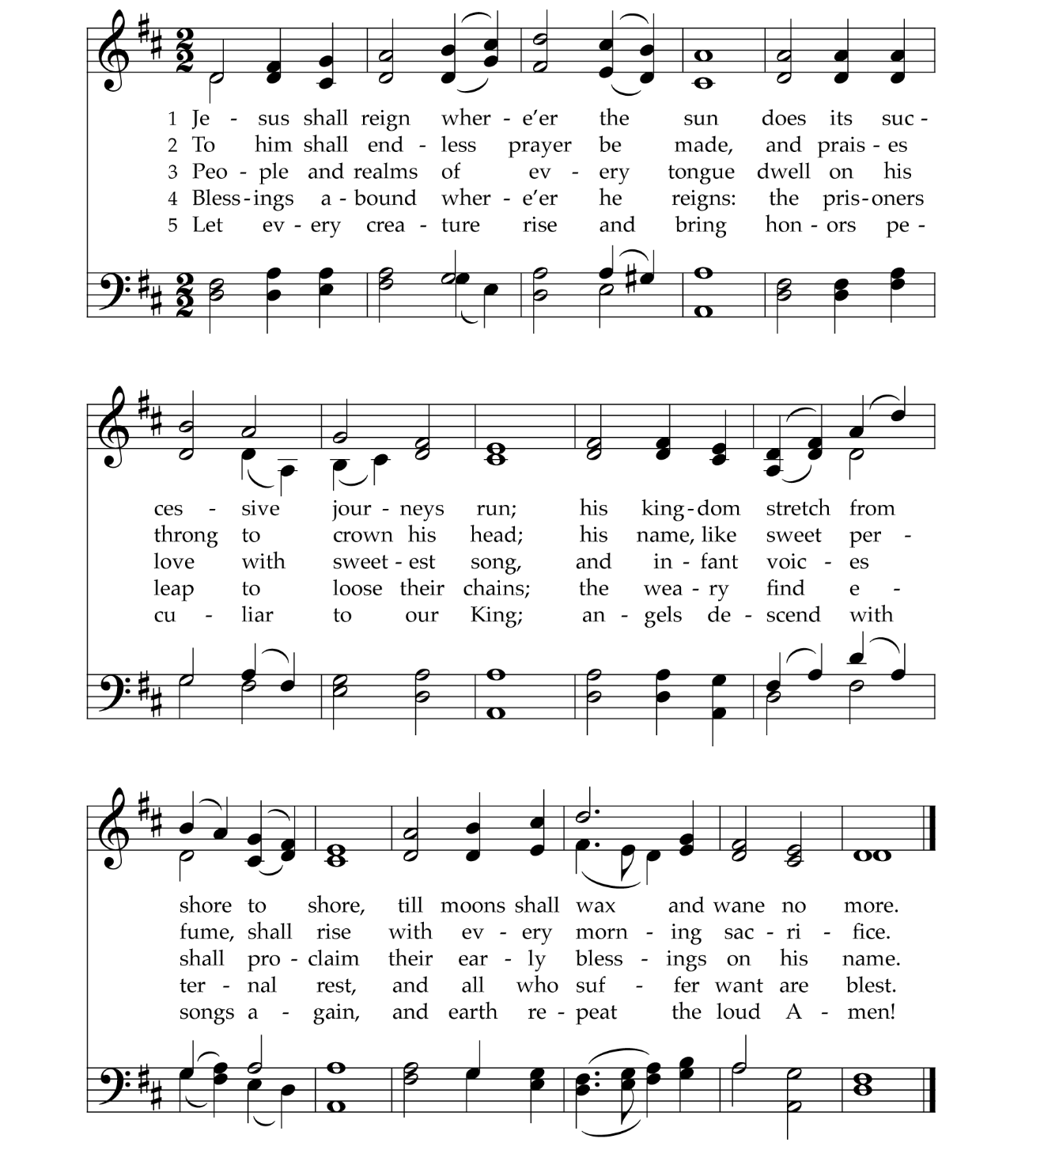

Hymn | For the Healing of the Nations | Lauda Anima
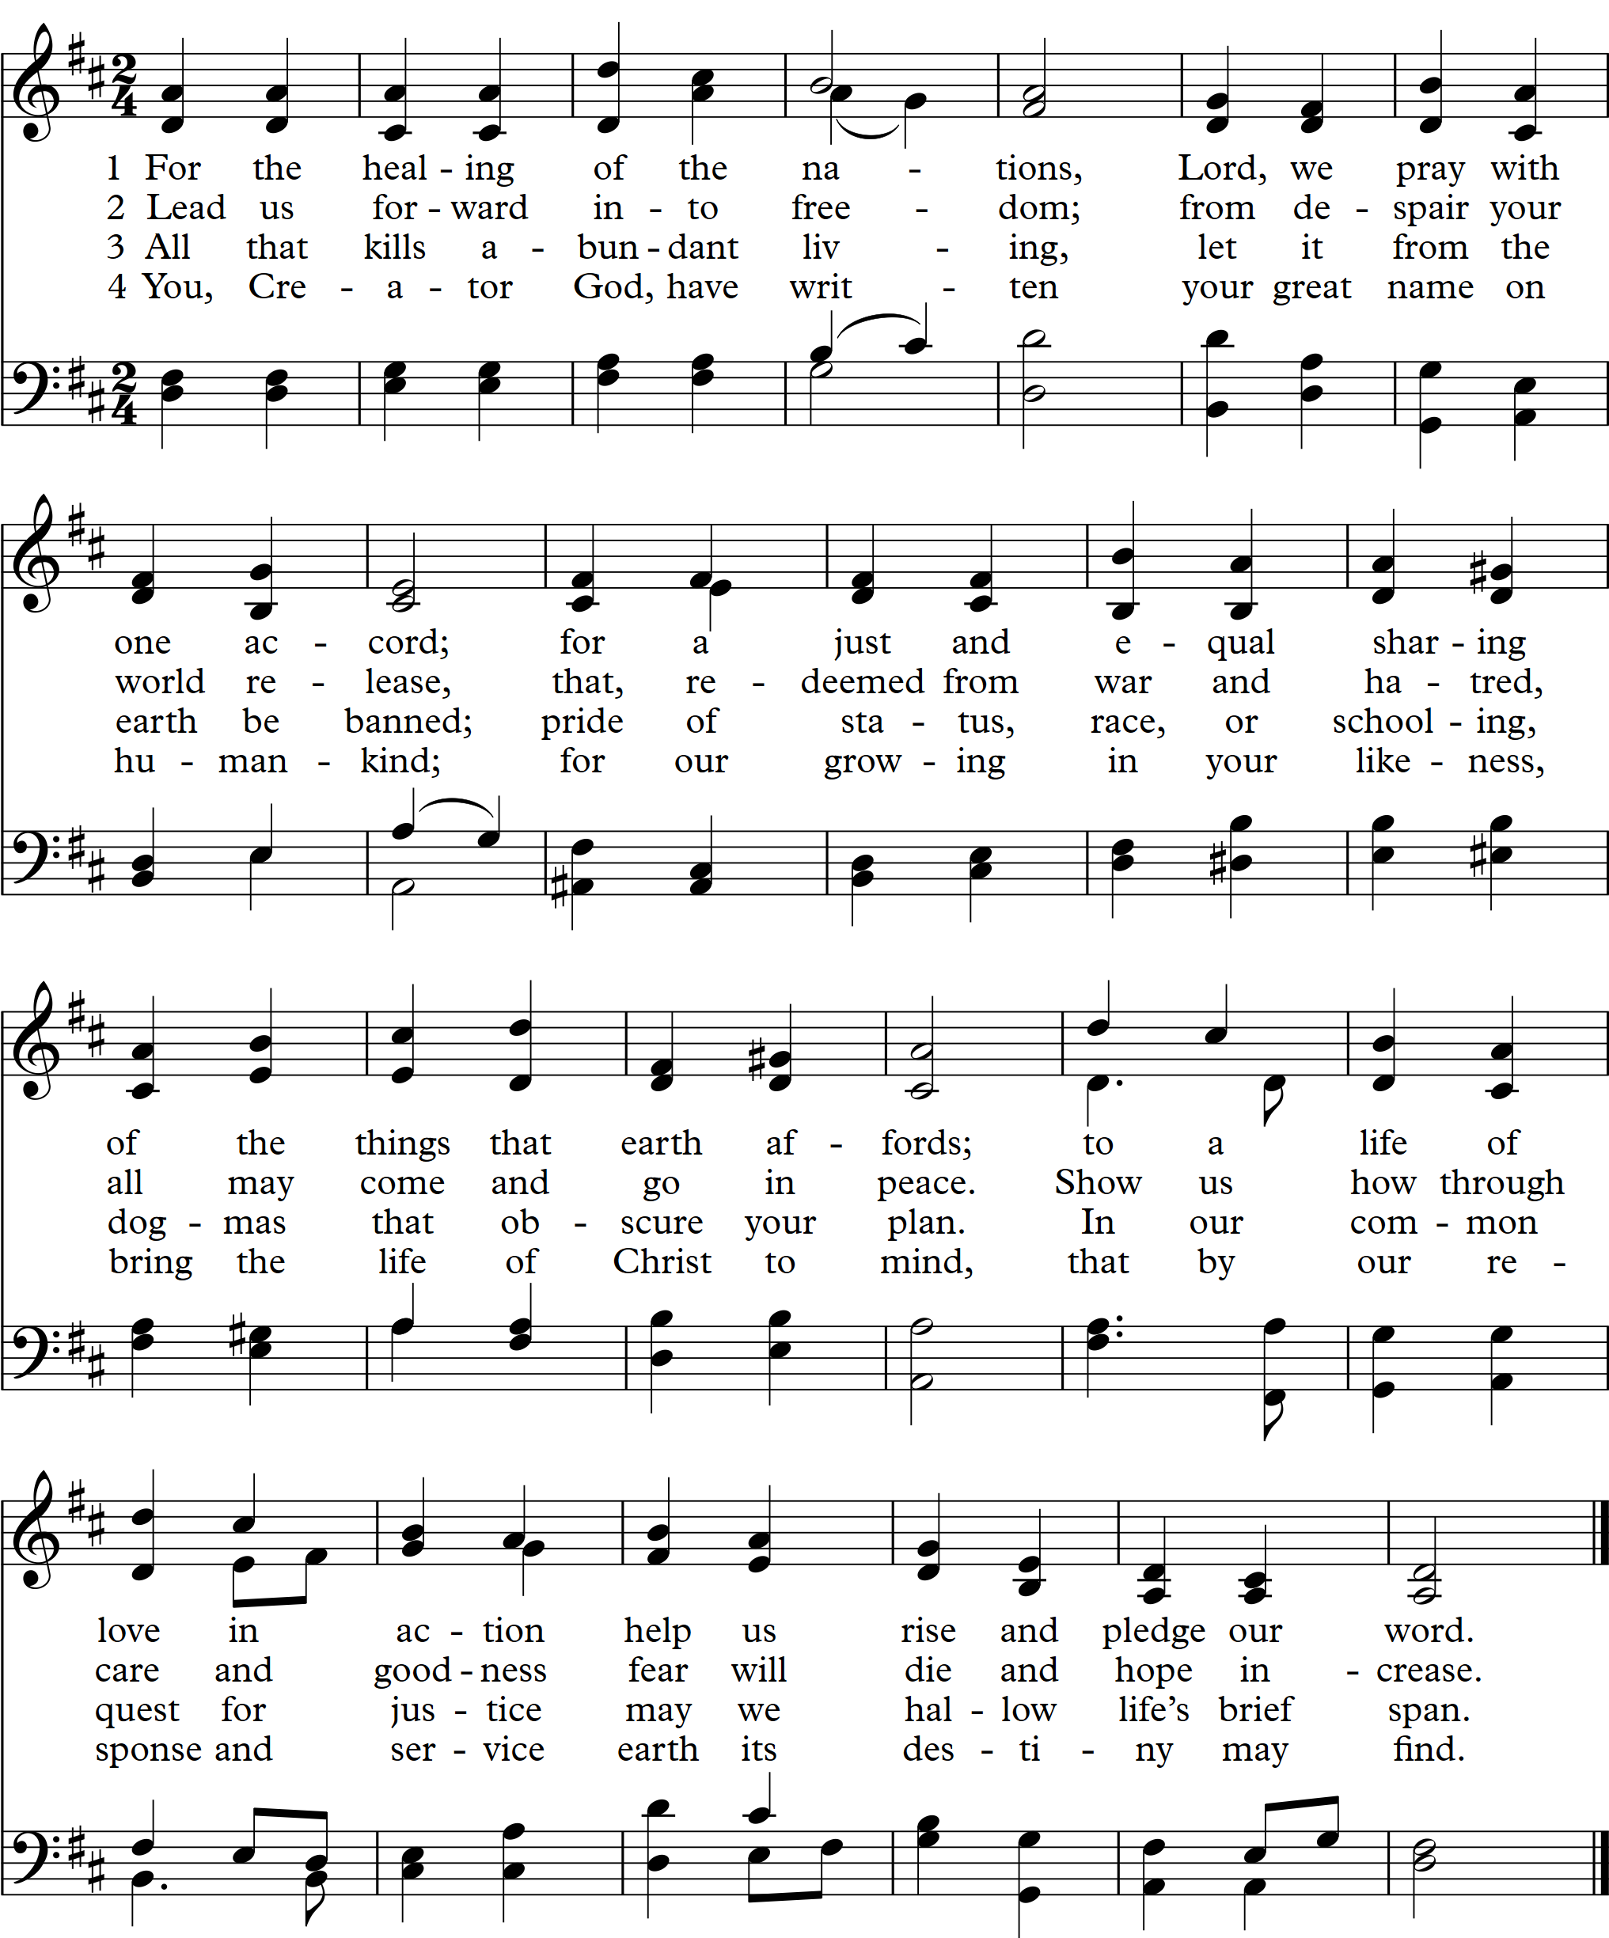

Hymn No. 490 | Wash, O God, Your Faithful Children | Beach Spring
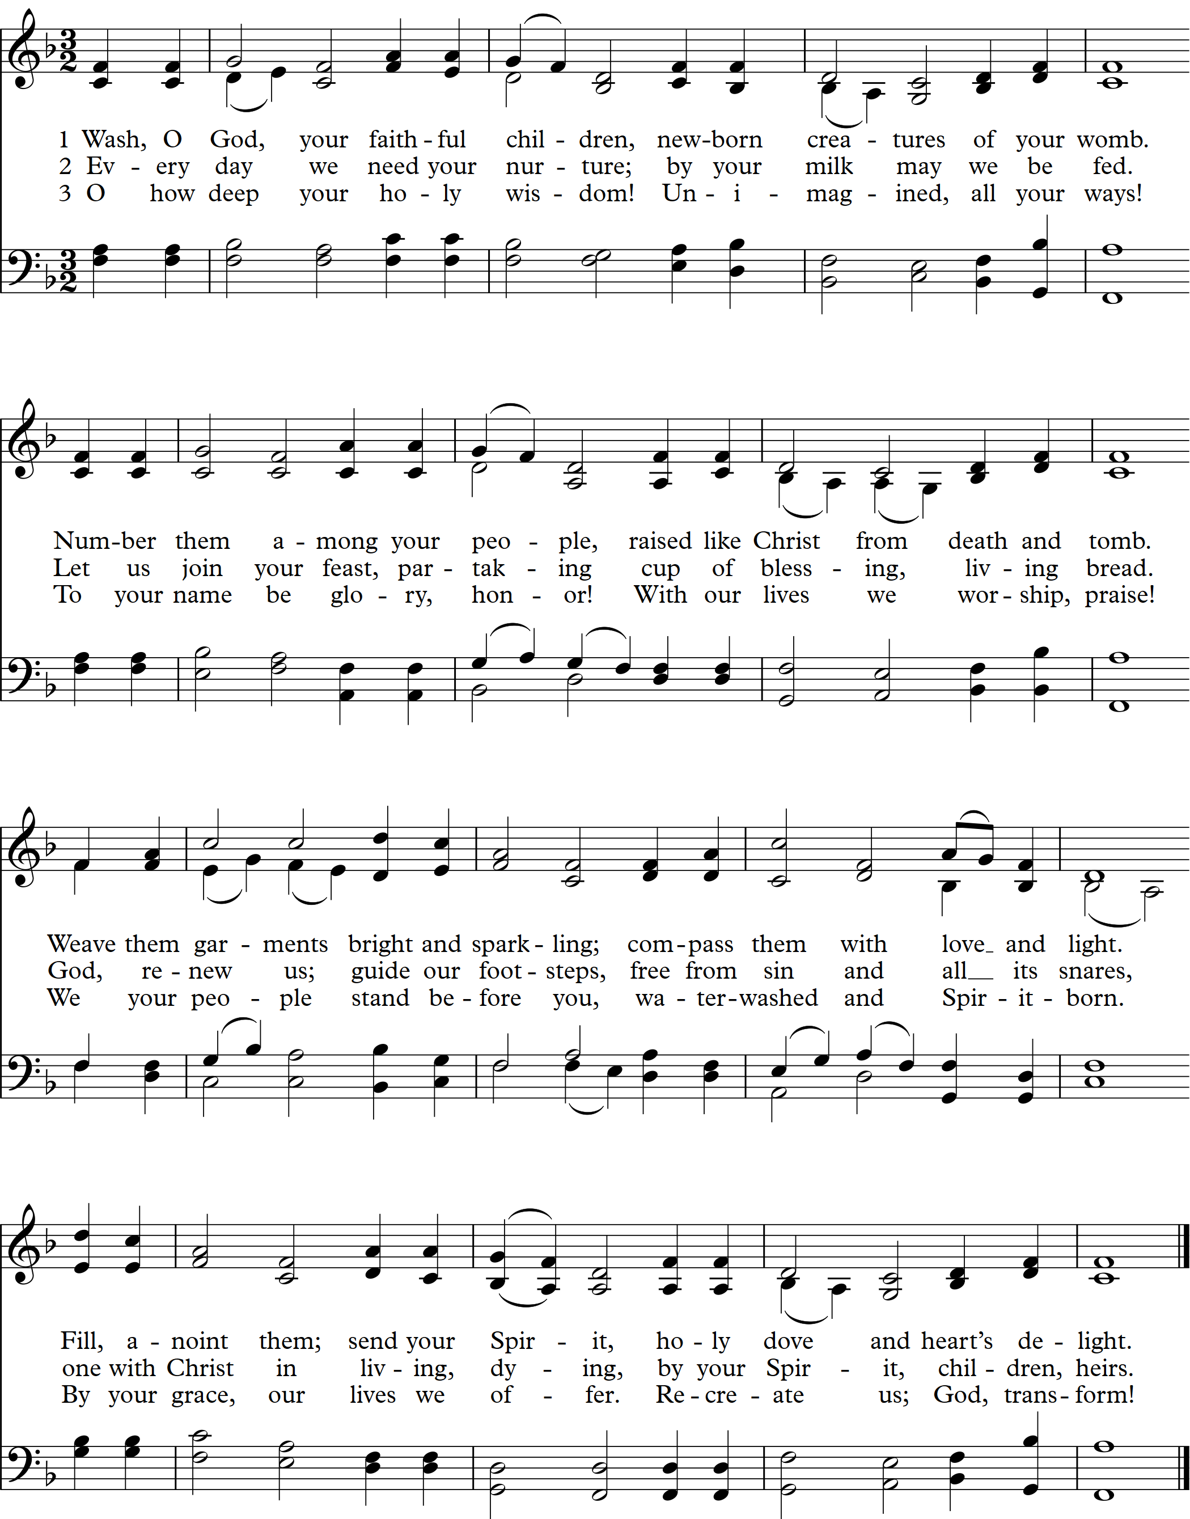

This Week at a Glance!
Sunday, July 19
Eighth Sunday after Pentecost
9:45 AM Adult Faith Formation (Lectionary Class)
9:45 AM Children’s Summer Faith Formation
11:00 AM Worship: Mindy Douglas, preaching
Monday, July 20  9:00 AM – 12:00 PM Walk-In Ministry  1:30 PM Worship Planning (Pastor’s Study)  4:30 PM Floor Yoga | Thursday, July 23  9:00 AM – 12:00 PM Walk-In Ministry  1:00 – 6:00 PM Red Cross Blood Drive  7:00 PM Youth: Homemade Ice Cream Hang-out  7:00 PM Somethings Summer Book Group
Friday, July 24
10:30 AM Chair Yoga
Tuesday, July 21 | Saturday, July 25  1:00 – 4:00 PM Ladies’ Tea (Fellowship Hall)
Wednesday, July 22
1:00 PM Staff Meeting (East Parlor)
Sunday, July 26
Ninth Sunday after Pentecost
Hunger for Change
Youth Leave for Montreat
9:45 AM Adult Faith Formation (Lectionary Class)
9:45 AM Children’s Summer Faith Formation
11:00 AM Worship: Esther Hethcox, preaching
Church Staff

Joseph Harvard, Pastor Emeritus
Esther Hethcox, Associate Pastor
Brandi Kirkland, Communications Associate
Matthew Moore, Minister of Music
Donald Turner, Facilities Associate
John Weicher, Associate Pastor
Janet Askew, Business Administrator
Lenore Champion, Director of Children’s Ministry
Vernon Cooper, Sexton
Mindy Douglas, Pastor/Head of Staff
Susan Dunlap, Parish Associate
Omar Guess, Sr., Sunday Morning Sexton

For more information about First Presbyterian Church, email the church office:
office@firstpres-durham.org or visit our website: https://firstpres-durham.org.

305 EAST MAIN STREET DURHAM, NORTH CAROLINA 27701 919.682.5511 ORGANIZED 1871

