|  |  |
| --- | --- |
| |  | | --- | | FIRST PRESBYTERIAN CHURCH  ﻿OF DURHAM  *"Downtown by history and by choice"*  *Bi-Weekly Newsletter*  **April 3 - 16, 2018** | |

|  |  |
| --- | --- |
| |  | | --- | | **From the Associate Pastor . . .**  Dear friends,  Durham has changed drastically in the last 10 years, no doubt: a skyscraper, trendy restaurants, DPAC, a parking crunch, and so many apartments. And yet, when we were walking the neighborhood streets as part of our Holy Week observance on Good Friday, the street scene seemed remarkably unchanged to me: cigarette butts and dandelions lining the cracked sidewalks, buses stopping to pick up and discharge riders and their bicycles, people hanging around outside Urban Ministries, cars with speakers blaring - oblivious to the solemn assembly, Amtrak passing at the appointed hour, and the faithful – walking the winding Via Dolorosa through Durham, feeling the heft of the rough hewn cross, sharing its weight with others, reliving the story of Jesus’ suffering, praying and singing along the journey. It always moves me.  But what moved me most this year was our shared journey with others. We gathered on Palm Sunday with our neighbors from Trinity UMC and St. Philip’s Episcopal to wave palms and to bless each other’s churches. We gathered again on Maundy Thursday at Covenant Presbyterian with their members and the members of Beacon of Light Missionary Baptist to wash feet and remember Jesus’ last supper and his command to “love one another”. And we gathered on Good Friday with the members of St. Philip’s, Covenant, and others to follow the old rugged cross and be reminded of the redeeming power of sacrificial love. We are not alone in this venture: that was my take-away from this year’s journey to Easter. We are not alone. We are surrounded by saints in the city who walk the Way of Jesus with us, together, side by side. Sometimes it requires taking a walk outside of your building to realize that you are not a lone disciple. Thanks be to God for our brothers and sisters in faith, the beloved community, who are empowered by the Risen Christ to anchor this city in love and faithfulness, as we grow and change together. Happy Eastertide to all the saints!  ***Marilyn*** | |

|  |  |
| --- | --- |
| |  | | --- | | **OUR JOYS AND CONCERNS** | |

|  |  |
| --- | --- |
| |  | | --- | | **Added this week**:  ***Norma Cardoni*,** mother of Sheila Breitweiser  ***Ching-Chang Chin***, father of Li-Chen Chin  ***Paul Martin,*** brother of Beth Neece  ***Rosemary Orphys***, aunt of Kerry Holbrook  *Traveling mercies for* ***Margaret and Miguel Rubiera***who are headed to Honduras on a Habitat Mission Trip with 37 quilts, handmade by FPC quilters.  ***Carsey Family Mary Clark Paul Cornsweet Graham/Seawell Family***  ***Julie Maxwell***  Brookdale Senior Living (Durham): ***Julian Boswell***  Croasdaile Village: ***Bette Conroy*, *Bob Rankin***  Croasdaile Pavilion: ***Bob Keever,*** ***John Kerr***, ***Florence Shackelford***  Pruitt Health at Carolina Point (Durham):***Helen Garrison***  The Forest at Duke: ***Fran Bryant, Peaches McPherson***  **Family and Friends of Church Members and Staff:**  ***Tom Birchfield***, step-father of Wil James  ***Claiborne Clark***, son ofArthur and Mary Clark  ***Marc Crawford***, friend of Brianna and Ricky Bennett  ***Kim Cummings***, father of Drew Cummings  ***Anna Gerwe & her family***, granddaughter of Barbara and Rod Gerwe  ***Heath, Rebecca, and Julia Huberg***, friends of Kathy Parkins and Mary Kay Robinson  ***Patricia Kost***, grandmother of Jack Kost  ***Ben Johnston-Krase***, pastor of Durham's Farm Church  ***Dell McMillian***, brother-in-law of Valerie McMillian  ***Sue Noel***, resident at Croasdaile Village and friend of Bill Hendrickson  ***Jonathan Pratt***, son of Lanny Pratt  ***Vickie Tobey***, niece of Mickey Velkey and cousin of Beth Brockman  ***Anne Turlington***, aunt of Jack Kost | |

|  |  |  |  |
| --- | --- | --- | --- |
| |  |  |  | | --- | --- | --- | | |  |  | | --- | --- | | |  | | --- | | https://imgssl.constantcontact.com/letters/images/1101116784221/S.gif | | | |

|  |  |  |  |  |  |
| --- | --- | --- | --- | --- | --- |
| |  |  |  |  |  | | --- | --- | --- | --- | --- | | |  |  | | --- | --- | | http://files.constantcontact.com/0bfd50e0601/20b13ba1-8b60-4810-92c6-53de9a72f593.jpg | https://imgssl.constantcontact.com/letters/images/sys/S.gif | | https://imgssl.constantcontact.com/letters/images/sys/S.gif | https://imgssl.constantcontact.com/letters/images/sys/S.gif |   Dear ***Marilyn*** (and FPC),  Thank you so much for your recent donation of 105 books to Book Harvest! Because of folks like you, we are able to provide books to children in our community who need them, to help build their literacy skills and fuel their imaginations. Since our founding in 2011, we have distributed 779,171 books to children here in the Triangle. Together, we are changing the literacy landscape one child and one home library at a time. Thank you for your partnership in that critical work.  Best regards,  ***Janet*** on behalf of Book Harvest  ******************  Thank you so much for your Christmas Eve offering of $1,318 donated during the holidays to provide 13,180 meals to those in your community who would otherwise wonder where their next meal was coming from. Thank you to all who made this possible. The Food Bank is so blessed to have supporters fighting hunger with us again this year.  With gratitude, ***Chandler Rock***  Food Bank of Central and Easter North Carolina | |

|  |  |  |  |
| --- | --- | --- | --- |
| |  |  |  | | --- | --- | --- | | |  |  | | --- | --- | | |  | | --- | | https://imgssl.constantcontact.com/letters/images/1101116784221/S.gif | | | |

|  |  |
| --- | --- |
| |  | | --- | | **PARISH NOTES**   * **MANY THANKS:** to ***Lenore Champion* and the CE Committee** for bringing the hot cross buns on a cold wintry morning to celebrate Palm Sunday; to ***Julie Whiddon* and the Fellowship Committee** for bringing brunch on Easter Sunday for our members and their many guests; to ***Jerry Postema* and the Worship and the Arts Committee** for oversight of three worship services on Easter Sunday; and to ***Michael Honeycutt* and the Pastoral Care Committee** for organizing the lovely reception following Dorothy Graham’s funeral on Easter Saturday. I concur with ***Mary Seawell*,** Dorothy’s daughter, that FPC is to be commended for the warm and compassionate ways that it wraps caring arms around those in need. Our congregation has grown in this way, and it is a beautiful thing to see. * The Friday morning Bible Study returns to finish our study of “Cultivating Christian Character: the Fruits of the Spirit”, taking a look at “gentleness” this Friday, and “self-control” on April 13. We will conclude our study on April 20th with a celebration brunch (at which we will practice self-control!). The class is open to everyone, on Fridays from 10:30 – noon at the church. ***Marilyn Hedgpeth*** leads the class and would love to have you join us as a Lenten practice. * The Lenten elective, *Holy Listening: Poetry Reading and Writing*, which used poetry as a lens for focusing our attention on God, has ended. But members of the class have requested that we continue, perhaps on a monthly basis, bringing poems to share, writing poems to share, looking at Biblical poetry, and considering how metaphor and image form us spiritually. Since most good poetry is essentially about love or death, and since we will be on the other side of Easter/Resurrection Day, **the group would like to meet again on Sunday, April 15 from 5 – 6 p.m. in room 205**, to discuss and share poems that deal with loss and/or death (their request).  Anyone is welcome to bring some interesting poems to share, and to join us around the table. ***Marilyn Hedgpeth*** is the facilitator. * **Membership Inquiry Classes** will continue on Sunday, April 8 from 9:45 – 10:45 in the **Wilson Parlor** through April 29. *We do not require anyone to take these classes before joining; you are welcome to join at any time, as your schedule allows.* Just let the pastors know if you are ready to join, and we’ll convene the Session of the church to make that happen. These classes are an opportunity for you to ask your questions, and to make an informed decision with knowledge of the history, ministry and mission of First Presbyterian Church. Know that we would love to include you and get to know you better.   **Remaining classes until new members are received:**  April 8 – History and Theology (9:45)  led by **Mindy Douglas**  April 15 – Liturgical Year and Worship (9:45)  led by **David Smith**  April 22 – Presbyterian Polity and Theology (9:45)  led by **Phyllis Supple**  April 29 – The Christian Life/Meeting with the Session (9:45)   led by **Mindy Douglas**  Those who wish may join during the worship service at 11:00 on April 29.   * **CROP Hunger Walk:** Thank you to everyone who supported the FPC team at the CROP Hunger Walk this past Sunday. Our team had almost 30 walkers and we have received pledges or donations from 50 different church members! Remember to turn in your donation if you sponsored a walker (it's not too late if you would still like to make a pledge to the team!). **Please make checks payable to Durham CROP Walk and give to the walker you are sponsoring or to Jody Maxwell.**  The Durham CROP Walk will raise over $75,000 this year and is the 2nd largest CROP walk in the US. Our congregation plays a big role in making this such a successful event!*-* ***Jody Maxwell*** | |

|  |  |  |  |  |  |  |  |  |  |
| --- | --- | --- | --- | --- | --- | --- | --- | --- | --- |
| |  |  |  | | --- | --- | --- | | |  |  | | --- | --- | | |  | | --- | | https://imgssl.constantcontact.com/letters/images/1101116784221/S.gif | | | | **Communion during Eastertide** |  |  |  |  |  |  | | --- | --- | --- | --- | --- | | |  |  | | --- | --- | | http://files.constantcontact.com/0bfd50e0601/0e50eb6d-010a-423c-b0a6-31dba3013db9.jpg | https://imgssl.constantcontact.com/letters/images/sys/S.gif | | https://imgssl.constantcontact.com/letters/images/sys/S.gif | https://imgssl.constantcontact.com/letters/images/sys/S.gif |   We will be celebrating the sacrament of Holy Communion every Sunday during Eastertide (April 1 - May 13). **We are asking that you consider bring blessing bag supplies (or ready-made bags) on this Sunday, April 8 and again on Sunday, May 6.** | |

|  |  |  |  |
| --- | --- | --- | --- |
| |  |  |  | | --- | --- | --- | | |  |  | | --- | --- | | |  | | --- | | https://imgssl.constantcontact.com/letters/images/1101116784221/S.gif | | | |

|  |  |
| --- | --- |
| |  | | --- | | **Sunday, April 8**  **2nd Sunday of Easter**  **9:45 a.m. Sunday School/Membership Inquiry Class**  **11:00 a.m.** **Worship and Communion**  **Mindy Douglas, preaching**  Liturgist: ***Jane Wettach***  ﻿Narthex Greeter: ***Maxie Honeycutt***  After Worship Greeters: ***Jo Bernhardt*** (side/font); ***Al Arrowood*** (rear/narthex)  Head Usher: ***Stephen Berry***  Communion Elders:  HEAD/Replenish elements: ***Gray Wilson***  BREAD: ***Alice Raney*** (B1/process), ***Al Arrowood*** (B2), ***Andy Henry*** (B3), ***Delia Kwon*** (B4)  CUP: ***Jo Bernhardt*** (C1), ***Barbara Buckley*** (C2/process), ***Lenore Champion*** (C3), ***Sigfried Fullenkamp*** (C4)  SHEPHERDS: ***Miriam Morey*** (center aisle), ***Caroline Rourk*** (font aisle), ***Eric Wiebe*** (pulpit aisle) | |

|  |  |  |  |
| --- | --- | --- | --- |
| |  |  |  | | --- | --- | --- | | |  |  | | --- | --- | | |  | | --- | | https://imgssl.constantcontact.com/letters/images/1101116784221/S.gif | | | |

|  |  |
| --- | --- |
| |  | | --- | | **Sunday, April 15**  **Third Sunday of Easter**  From the Associate Pastor . . .    **Stories of Resurrection: Christ is Risen**  In small faith groups, where sharing the scriptures has led to deeper bonds of trust that surprise people;  In families torn by strife that have reached out for professional help and begun to put back together pieces of broken relationships;  In the lonely nightmare of an addict “hitting bottom” and turning to treatment for help;  In weary peace negotiators tempted to give up but willing to try again and again to stop senseless violence and killing in the middle east;  In urban ministries and homeless shelters where a word of compassion is spoken to a sister or brother more in need of kindness than a handout;  In cancer wards and ICU where the value of human life is reverenced and human dignity restored by the selfless service of health care workers and a compassionate church;  In endless hours of meetings with committees and ministry groups with staff where generous gifts of time and talent are offered for the good of the community;  In the wonderful discovery of self-worth by an insecure adolescent, finding acceptance from peers and caring adults;  In the man or woman in the unemployment line who has lost a job but in the process discovered what really matters in life;  In the bitter pains of grief, gently assuaged by a caring community when loved ones die: ***Bill Lorimer, Tom Carsey*** and ***Dorothy Graham***;  In the anger dispelled as forgiveness takes hold and reconciliation happens;  In the struggle to recover from disabling illness or the facing of terminal illness with faith;  In political and social policies that show compassion to the prisoner, the hungry, the helpless and a preference for the poor;                     … IN ALL THESE PLACES AND MORE, CHRIST IS RISEN!  ***Sam Miglarese***  ***\*\*\*\*\*\*\*\*\*\*\*\*\*\*\*\*\*\*\*\*\****  **9:45 a.m. Sunday School / Membership Inquiry Class**  **11:00 a.m.  Worship and Holy Communion**  **Sam Miglarese, preaching**  **The Children's Choir** will sing during worship.  Liturgist: ***Carl Rist***  Narthex Greeter: ***Alice Raney***  After Worship Greeters: ***Barbara Buckley*** (side/font); ***Carol Carson*** (rear/narthex)  Head Usher: ***Emily Wilkins***  Communion Servers:  HEAD/Replenish elements: ***TBD***  BREAD: ***Jane Williams*** (B1/process), ***Dewey Lawson*** (B2), ***Jo Bernhardt*** (B3), ***Gerald Postema*** (B4)  CUP: ***Ellie Dilworth*** (C1), ***Libby Gulley*** (C2/process),***Karen Romines*** (C3), ***Eric Wiebe*** (c4)  SHEPHERDS: ***Gray Wilson*** (center aisle), ***Brent Curtis*** (font aisle), Carol ***Carson*** (pulpit aisle)  ***﻿*** | |

|  |  |
| --- | --- |
| |  | | --- | | **SUNDAY SCHOOL / CHRISTIAN EDUCATION** | |

|  |  |
| --- | --- |
| |  | | --- | | Children’s and Youth Sunday School are wonderful examples of small group ministry in our church. For the 3-5th graders, ***Li-Chen Chin***and ***Marilyn Hedgpeth*** will meet you in the Spirituality Room for some singing, fellowship, and active prayer on **April 8**. Then on **April 15** we’ll hear the story of Jesus asking Peter again to follow him (John 21: 15-27). I wonder what he’ll ask Peter to do? Do you know?  Have you heard the story?  ***************************    **Middle and high school youth classes meet at 9:45 a.m. in their lower level classrooms.**  ****************************  **Faith and Community Class:** Connections matter for children.  The future of NC and our communities depends on our ability to foster the healthy development of the next generation. Extensive research on the biology of stress now shows that healthy development can be derailed by excessive or prolonged activation of stress response systems in the body and brain. Learn this Sunday about how faith communities like First Presbyterian can build resilience and safe, stable, nurturing relationships and environments to strengthen families and keep children safe.  April is National Child Abuse Prevention Month and Sharon Hirsch, President & CEO at Prevent Child Abuse NC, will lead our discussion about the ways our community can build connections and supports so that children can thrive.  In addition, ***Christyn Klinck*** has an interesting opportunity for us to donate used ipods to benefit those struggling with memory loss.  Then on **April 15**, we welcome back ***David Reese***, President and CEO of East Durham Children’s Initiative. Founded in 2009, EDCI has celebrated many milestones since its inception. Come and hear about the progress of this outreach to at-risk children and their families. **Faith and Community meets in Watts-Hill Hall from 9:45 – 10: 45, and all are welcome!**    ******************  **Lectionary Class**: Join us for discussion at 9:45 in the East Parlor.    **April 8:**  Can a community exist if the members do not all agree? Can a community of faith exist if some members do not believe?  **April 15:**  When you have witnessed something important, you have a duty to testify. But sometimes there are consequences. Are you willing to be a witness? Are you willing to get involved?   *******************  **Journeys and Scratch/Young Adults Class:**  We meet in the corner room of the 2nd floor of the education building.  *******************  **Spiritual Formation** This year-round class for women is led by ***Susan Dunlap*** and explores the topic of spiritual formation. Join us at 9:45 in basement classroom B-16. | |

|  |  |  |  |
| --- | --- | --- | --- |
| |  |  |  | | --- | --- | --- | | |  |  | | --- | --- | | |  | | --- | | https://imgssl.constantcontact.com/letters/images/1101116784221/S.gif | | | |

|  |  |  |  |
| --- | --- | --- | --- |
| |  |  |  | | --- | --- | --- | | |  |  | | --- | --- | | http://files.constantcontact.com/0bfd50e0601/274f9313-69ba-4efd-a6c6-f92eae8326dd.jpg | https://imgssl.constantcontact.com/letters/images/sys/S.gif |   **Sunday, April 8 - High School youth Mystery Day**  **(Middle School youth – activity TBA)**  **Sunday, April 15**  **5 – 8 PM Youth Groups (Service Project)** | |

|  |  |  |  |
| --- | --- | --- | --- |
| |  |  |  | | --- | --- | --- | | |  |  | | --- | --- | | |  | | --- | | https://imgssl.constantcontact.com/letters/images/1101116784221/S.gif | | | |

|  |  |
| --- | --- |
| |  | | --- | | **Sunday, April 8**  **David LaMott Workshop for Youth**  ***"Challenging the Myth of Powerlessness"***  **for ages 14 and up**  **Judea Reform Congregation will open doors at 1:30 p.m.**  **Two-Part Workshop is from 2:00 - 6:00 p.m.**  **David LaMotte** has presented keynotes and workshops on five continents, appearing along the way, either as a speaker or a musician, with well-known world changers such as Desmond Tutu, Pete Seeker and civil rights hero John Lewis. In this workshop, LaMotte questions prevailing narratives about how the world changes and how it does not. Encourage people to engage with the world around them and address the problems they see, he methodically builds a case for both our capacity and responsibility to make a difference. If you are interested in going, contact Marilyn Hedgpeth. Click [*here*](http://www.worldchanging.brownpapertickets.com/) for ticket information. | |

|  |  |  |  |
| --- | --- | --- | --- |
| |  |  |  | | --- | --- | --- | | |  |  | | --- | --- | | |  | | --- | | https://imgssl.constantcontact.com/letters/images/1101116784221/S.gif | | | |

|  |  |  |  |  |  |
| --- | --- | --- | --- | --- | --- |
| |  |  |  |  |  | | --- | --- | --- | --- | --- | | |  |  | | --- | --- | | http://files.constantcontact.com/0bfd50e0601/6f1ace9a-9245-45ab-a237-8a7b2658c4d1.jpg | https://imgssl.constantcontact.com/letters/images/sys/S.gif | | https://imgssl.constantcontact.com/letters/images/sys/S.gif | https://imgssl.constantcontact.com/letters/images/sys/S.gif |   If landscaping is your niche, join **Barbara Buckley** and her team of faithful volunteers in another workday at the church!  **Saturday, April 7**  **9:00 a.m. - 12 noon**  Contact Barbara if you can help!  [bjbuckley1@frontier.com](mailto:bjbuckley1@frontier.com) or 919-210-0482. | |

|  |  |  |  |
| --- | --- | --- | --- |
| |  |  |  | | --- | --- | --- | | |  |  | | --- | --- | | |  | | --- | | https://imgssl.constantcontact.com/letters/images/1101116784221/S.gif | | | |

|  |  |
| --- | --- |
| |  | | --- | | Scratch Brunch for April  Saturday, April 7 from 10:30 – noon  at Marilyn Hedgpeth’s home ([1812 Cole Mill Rd.,](https://maps.google.com/?q=1812+Cole+Mill+Rd.++Durham,+NC+27712&entry=gmail&source=g) Du[rham](https://maps.google.com/?q=1812+Cole+Mill+Rd.++Durham,+NC+27712&entry=gmail&source=g))   Scratch members and their children (Marilyn has a very child-friendly home) are invited! **Bring a potluck breakfast item to share PLUS one cup of cut up raw veggies** (potatoes, carrots, root veggies, celery, onion, squash, tomatoes, green beans) to make Stone Soup, which Marilyn will add to the broth and cook, package and freeze for future needs of the Scratch group (new babies, accidents, visitors, hunger, etc.).  We’ll read Marcia Brown’s classic*, Stone Soup*, together, as a reminder of what good community looks like.  Please reply via the EVITE. Not getting the EVITE? Contact Valerie in the church office to be added to the EVITE listserv. | |

|  |  |  |  |
| --- | --- | --- | --- |
| |  |  |  | | --- | --- | --- | | |  |  | | --- | --- | | |  | | --- | | https://imgssl.constantcontact.com/letters/images/1101116784221/S.gif | | | |

|  |  |
| --- | --- |
| |  | | --- | | Kinston Mission Trip  FPC is returning to Kinston June 24 – 29 to rebuild homes damaged by Hurricane Matthew. Participants must be 14 or older, and we are seeking a range of youth and adults to form this team. We will again stay at FPC – Kinston and work with K.A.R.E, the local recovery effort. A $150 fee is requested for food and lodging expenses, but scholarships are available. **Please attend an interest meeting after worship on Sunday, April 8.** We hope to have the team assembled by the end of May. Please contact Tyler Momsen-Hudson for more information. [***tylermmh@embarqmail.com***](mailto:tylermmh@embarqmail.com). | |

|  |  |  |  |
| --- | --- | --- | --- |
| |  |  |  | | --- | --- | --- | | |  |  | | --- | --- | | |  | | --- | | https://imgssl.constantcontact.com/letters/images/1101116784221/S.gif | | | |

|  |  |
| --- | --- |
| |  | | --- | | **Presbyterian Women** will meet again for **Circle and Bible Study** on **Monday, April 9 at 10:30 a.m. in the East Parlor.**  **\*\*\*\*\*\*\*\*\*\*\*\*\*\*\*\*\*\*\***  **First Friends and Families Spring Hike**  **SAVE THE DATE: Saturday, April 21**  We're hiking the Occoneechee Mountain Trail in Hillsborough from 4 - 6 p.m.  Please respond to the EVITE.  *******************  **New Officers Training**  **SAVE THESE DATES**  **Sunday, April 22**  12:30 – 2:00 p.m. **at FPC**.  New Deacons and new elders will train in separate class spaces.  **Sunday April 29**  1:00 – 3:00 p.m. **at FPC** with Trinity Avenue PC officers  All new officers; class led by ***Art Ross***  **Sunday, May 6**  1:00 – 3:00 p.m. **at Trinity Ave PC**  All new officers; class led by ***Art Ross***  *******************  **Seniors Spring Luncheon**  **SAVE THE DATE: Wednesday, April 25**  **11:30 a.m. gather in the Wilson Parlor**  **12 Noon Luncheon in Watts-Hill Hall**  **Presentation by Dennis Dunlap**  ******************  **PrimeTimers' Covered Dish Supper**  **SAVE THE DATE: Friday evening, April 27**  **6:30 p.m. at the home of Andy and Ginny Widmark**  Details forthcoming! Watch for the EVITE.  ****************  **Upcoming Events for Families with Young Children**  Many thanks to all of you who turned out for a chilly Easter Egg Hunt and Palm Parade on Palm Sunday. Fortunately, we had hot cross buns to warm us up and an invigorating Crop Walk later that afternoon! These are all wonderful, tactile ways to involve families together in the story of Easter. Our next gathering will be **Sunday, April 22 from 5:00 – 6:15 p.m.**, when parents will step out for a bite to eat, while children learn a little about building robots from ***Sigfried Fullenkamp***. Should be VERY interesting!  ********************  **Registration has begun for this summer’s GBCFF** (Great Big Church Family Festival), June 17, 18, and 19th at participating churches, from 5:30 – 7:30, and an August 5 reunion at Camp New Hope, with swimming, pot-luck, singing, and games. This year’s theme is “Serve the Lord with Gladness”, and each evening will involve dinner, crafts, and a service project that all can participate in together. GBCFF is for children of God young and old.  Use this link to sign up: <https://docs.google.com/forms/d/e/1FAIpQLSfX8dH3PZ2gWINYw7s2hKVp7iTXqHn1Y-lwCYjdmkS0QYKwrA/viewform?usp=sf_link> | |

|  |  |  |  |
| --- | --- | --- | --- |
| |  |  |  | | --- | --- | --- | | |  |  | | --- | --- | | |  | | --- | | https://imgssl.constantcontact.com/letters/images/1101116784221/S.gif | | | |

|  |  |
| --- | --- |
| |  | | --- | | Ongoing opportunities for service at UMD:  Month after month, dedicated volunteers from our congregation head down the street to Urban Ministries to help prepare and serve meals to our neighbors in need. In addition to serving meals, we also have quite a few members who are helping sort and organize donated clothes to make them available for the many people who walk through the door of Urban Ministries seeking assistance. Other volunteers answer the call to help with special projects, such as stuffing envelopes for large mailings. If you would like to be on the email list to be the first to hear of these opportunities, please contact ***Margaret Rubiera*** at [***margaretmr29@gmail.com***](mailto:margaretmr29@gmail.com). Every little bit that we do makes a significant difference, and we are the richer for the time we give to others. | |

|  |  |
| --- | --- |
| |  | | --- | | Community Invitations | |

|  |
| --- |
|  |

|  |  |  |
| --- | --- | --- |
| |  | | --- | | **2018 Bread for the World Convention** | | The 2018 North Carolina Bread for the World Convention, scheduled for **Saturday, April 7**, is rapidly approaching. This year’s theme is “Spiritual Politics: Resisting the Impending Hunger Crisis.” Again this year, the convention will be held at St. Philip’s Episcopal Church in downtown Durham. **Registration is open at** [***https://spiritualpolitics.eventbrite.com***](https://spiritualpolitics.eventbrite.com/)**.** Individual pre-registration is just $25 per person. A discounted rate of $15 is available for students. Scholarships also are available upon request. Simultaneous translation into Spanish will be available throughout the day. This year’s keynote speaker will be ***Michael Becketts***, former director of the Durham County Department of Social Services and now Assistant Secretary for Human Services at the North Carolina Department of Health and Human Services. Plan now to attend. | |

|  |  |  |  |
| --- | --- | --- | --- |
| |  |  |  | | --- | --- | --- | | |  |  | | --- | --- | | |  | | --- | | https://imgssl.constantcontact.com/letters/images/1101116784221/S.gif | | | |

|  |  |
| --- | --- |
| |  | | --- | | **FAITH CONNECTIONS ON MENTAL ILLNESS**  **Cultivating Mental Health: Hope and Healing** is a day-long interfaith conference to explore ways faith communities can support families and individuals living with mental illness. It will focus on addiction, depression in the elderly, and mental health resources available in the community. This conference will be held at **St. Thomas More Catholic Church in Chapel Hill on Friday, April 13 from 8:00 a.m. to 4:15 p.m.**  Click [***register***](http://www.faithconnectionsonmentalillness.org/annual-conference.html) to learn more about the conference and to register. | |

|  |  |  |  |
| --- | --- | --- | --- |
| |  |  |  | | --- | --- | --- | | |  |  | | --- | --- | | |  | | --- | | https://imgssl.constantcontact.com/letters/images/1101116784221/S.gif | | | |

|  |  |
| --- | --- |
| |  | | --- | | BBQ Church Worship and Conversations on Evangelism  Friday, April 13 from 6:00 - 8:30 pm.  FPC, Wilson - 414 Sunset Road NW, Wilson (252-243-3115)  BBQ Church Worship led by ***John West***, Professor of Evangelism of Union Presbyterian Seminary; Experience church around a table in a way that is contextual, casual and surprisingly flavorful. Reservations are required. The service is free, but your donation helps to cover the cost of dinner and music.  Saturday, April 14 from 9:00 a.m. - 12:30 p.m. at FPC, Wilson  Conversations on Evangelism workshop led by ***John West***. Cost is $30 and includes a continental breakfast. Proceeds support the Evangelism Program at Union Seminary.  Register online:www.regonline.com/evangelism or contact ***Sterling Burton*** at [sburton@upsem.edu](mailto:sburton@upsem.edu) or 804-278-4373. Sponsored by Presbytery of New Hope, Union Presbyterian Seminary and FPC, Wilson. | |

|  |  |  |  |
| --- | --- | --- | --- |
| |  |  |  | | --- | --- | --- | | |  |  | | --- | --- | | |  | | --- | | https://imgssl.constantcontact.com/letters/images/1101116784221/S.gif | | | |

|  |  |
| --- | --- |
| |  | | --- | | **Durham CAN Public Assembly for Affordable Housing**  The time is now to show our support for affordable housing! Come to this Durham CAN Assembly; join our neighboring churches and agencies for a rousing call to include affordable housing in the development of the county lot next to our church. First Presbyterian and our neighbor St. Philips have been working toward this goal since 2015, and we are ready to make a joyful, loud public statement in these final days before the County Commissioners make their final decisions.  See our Session's joint statement of support for this plan on our website.  **When: Sunday, April 15, 2018**  **Time: 4:00 - 5:30 p.m.**  **Where: St. Philip's Episcopal Church, Fellowship Hall** | |

|  |  |  |  |
| --- | --- | --- | --- |
| |  |  |  | | --- | --- | --- | | |  |  | | --- | --- | | |  | | --- | | https://imgssl.constantcontact.com/letters/images/1101116784221/S.gif | | | |

|  |  |
| --- | --- |
| |  | | --- | | REI's Groundwater Presentation:  An Introduction to Racial Equity - Durham  Saturday, April 21, 2018 from 9:00 a.m. - Noon at Carolina Friends School  Contact Stephanie Baker: [***sbakeract@gmail.com***](https://www.oaralliance.org/schedule/groundwater) for more information. [***Register here.***](http://events.constantcontact.com/register/event?llr=kuoqakuab&oeidk=a07ef5xbgk5c953dc94) | |

|  |  |  |  |
| --- | --- | --- | --- |
| |  |  |  | | --- | --- | --- | | |  |  | | --- | --- | | |  | | --- | | https://imgssl.constantcontact.com/letters/images/1101116784221/S.gif | | | |

|  |  |
| --- | --- |
| |  | | --- | | Iglesia Emanuel Transforming and Serving:  Celebrating our Ministries  **Iglesia Emanuel** wants to spread the news about their very special and impactful ministries. On **Saturday, April 28, from 6:00 - 8:00 p.m.**, they are hosting a dinner, prepared by members of their church, which will be held in the fellowship hall of Trinity Avenue Presbyterian Church. Following the delicious dinner of tantalizing flavors from the various countries of origin of the church members, there will be musical entertainment as well as stories of the unique outreach projects of the church. Although there is no cost for the dinner, it is intended to be a fundraiser to help Iglesia Emanuel expand their ministry in the community, as well as an opportunity for people from various churches to come together in friendship and fellowship. Seating is limited, so if you would like to help support our sister church, please reserve your spot soon. Contact ***Margaret Rubiera*** at [***margaretmr29@gmail.com***](mailto:margaretmr29@gmail.com). | |

|  |  |  |  |
| --- | --- | --- | --- |
| |  |  |  | | --- | --- | --- | | |  |  | | --- | --- | | |  | | --- | | https://imgssl.constantcontact.com/letters/images/1101116784221/S.gif | | | |

|  |  |
| --- | --- |
| |  | | --- | | Durham Senior Games & Silver Arts  **﻿Monday, April 16 - Thursday, May 3, 2018**  Ages 50 or better may participate and volunteers are also needed!  For more information call or visit: 919-560-4355 ext. 27232 or DPRPlayMore.org | |

|  |  |
| --- | --- |
| |  | | --- | | **The next church newsletter will be issued April 17, 2018.**  **Please submit your articles / news to Valerie in the church office**  **by Sunday, April 15, 2018.** | |

Enjoy these photos from Easter Sunday 2018!

***(Courtesy of John Fricks)***

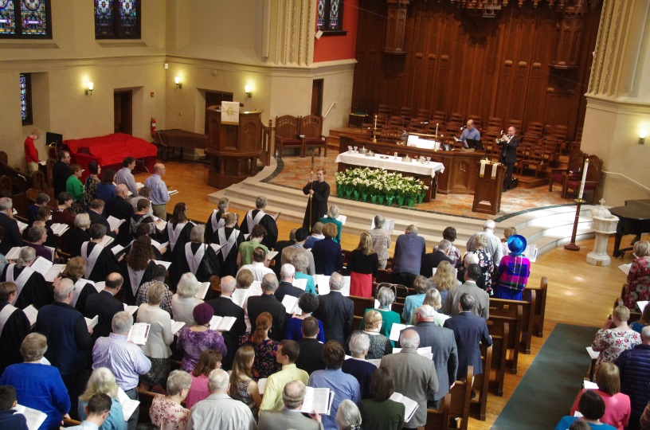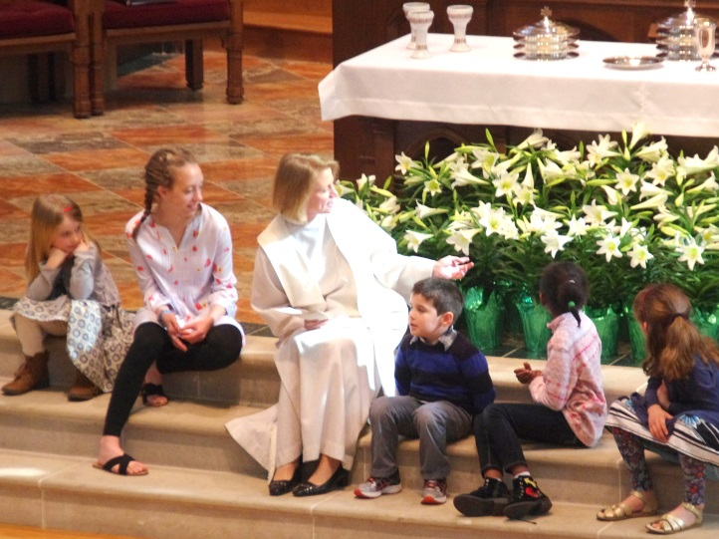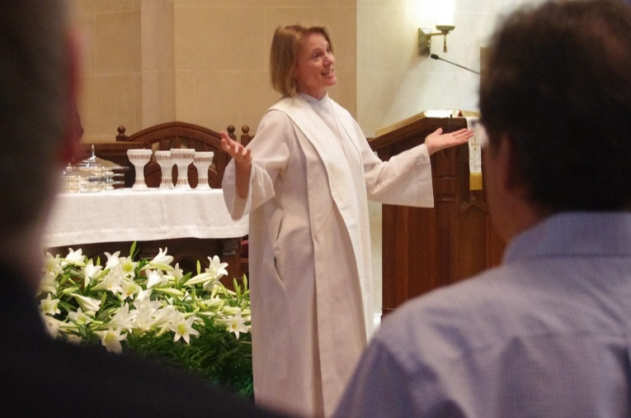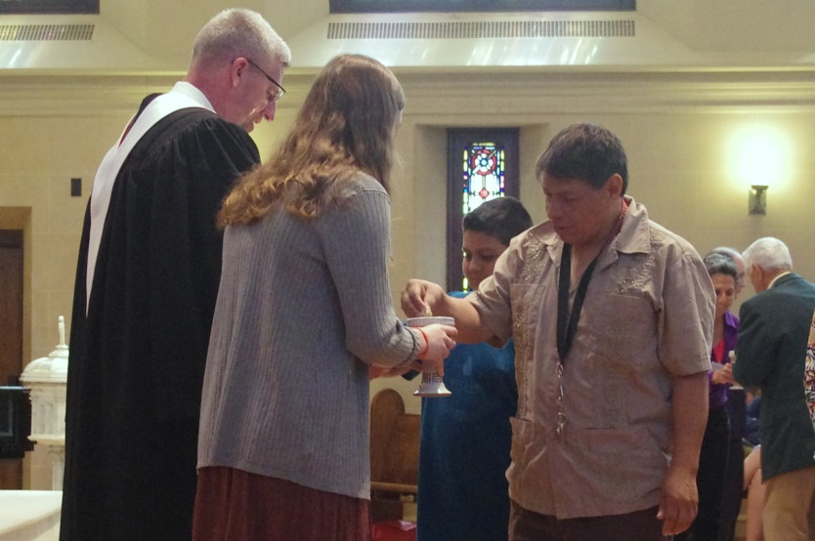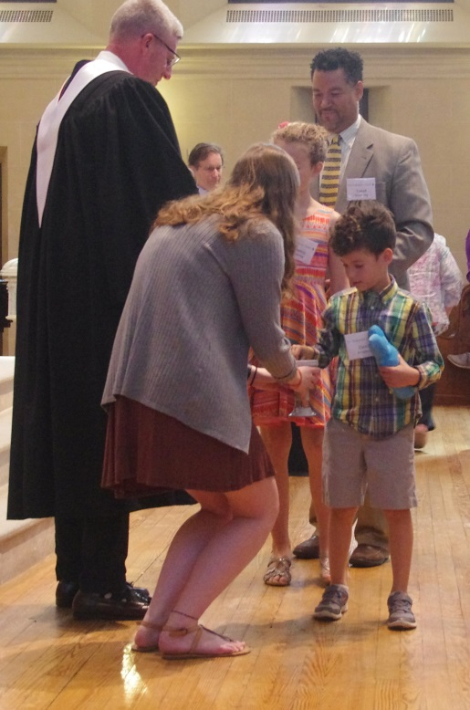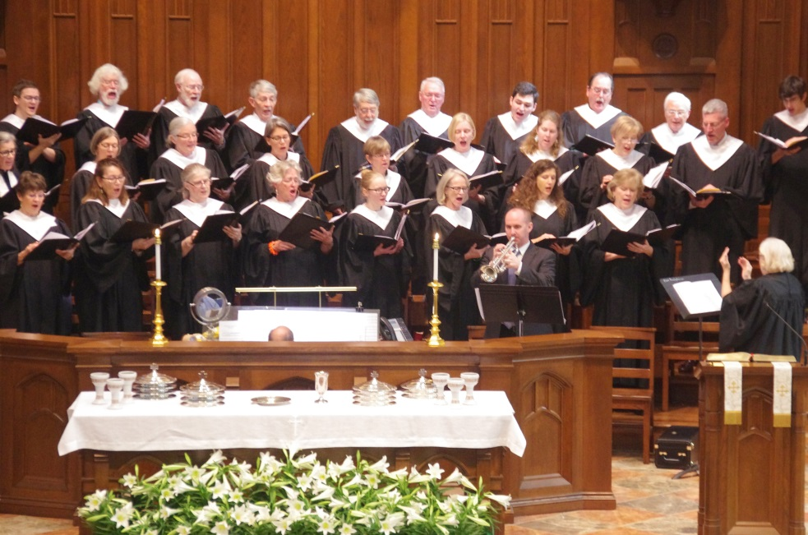

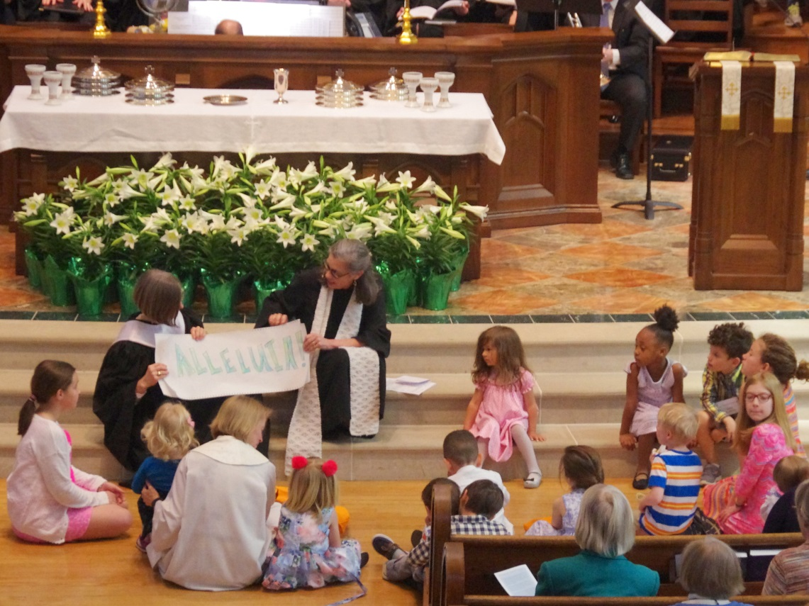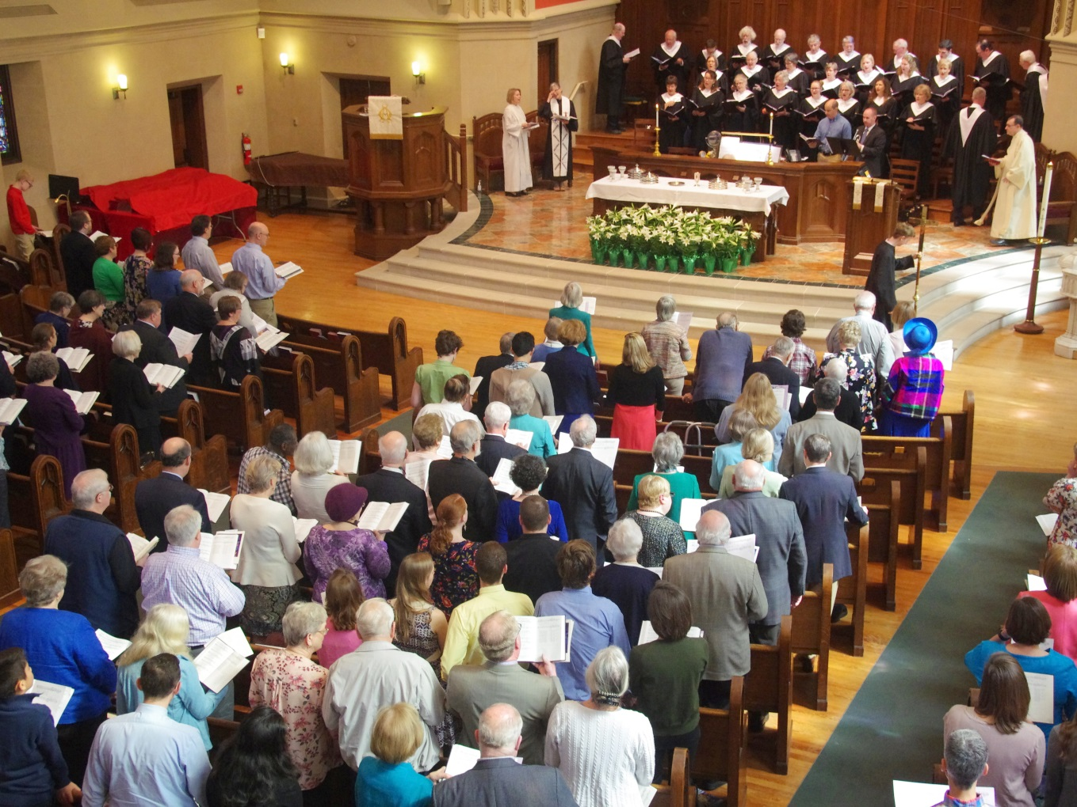

© 2018 First Presbyterian Church

First Presbyterian Church

305 East Main Street

Durham, NC 27701

919-682-5511 (office) 919-682-0493 (fax) https://firstpres-durham.org